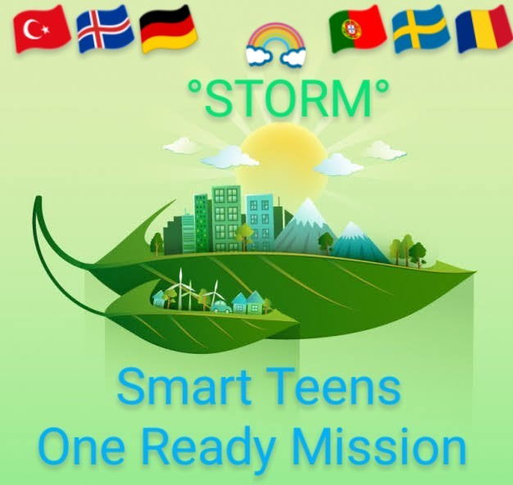

“STORM“

Smart Teens,One Ready Mission!

KEY ACTION2 CORPORATION FOR INNOVATION AND THE EXCHANGE OF GOOD PRACTICES

KA201 STRATEGIC PARTNERSHIPS FOR SCHOOL EDUCATION
Proje No: 2020-1-TR01-KA201-093199

LTT3 Türkiye MOBILITY

1-5 OCTOBER 2023 TRAVEL

2-4 OCTOBER 2023 ACTIVITY
HISTORY | DAY | HOUR | WORKS TO BE DONE | DESCRIPTIONS
01.10.2023 | SUNDAY |  | Arriving to Turkey.Check into the hotel
02.10.2023 | 1 ST DAY  MONDAY | 09.30 | Leaving the hotel
 |  | 10.00 | Arrival to school
 |  | 10.30-11.30 | Meeting at school
 |  | 11.30-12.15 | Evaluation of mobilities and work carried out by host countries | SWEDEN-ICELAND-PORTUGAL/MADEIRA- (15 MINUTES FOR EACH COUNTRY)
 |  | 12.15-12.30 | Coffee break
 |  | 12.30-13.00 | Evaluation of mobilities and work carried out by host countries | GERMANY-TURKEY (15 MINUTES FOR EACH COUNTRY)
 |  | 13.30-14.30 | Lunch
 |  | 14.30-15.30 | Project teachers of partner countries (10 teachers) and all project teachers of the coordinator country will work on the results obtained during the project process (in the 1st, 2nd and 3rd years).
 |  | 15.30-15.45 | Coffee break
 |  | 15.45-17.15 | Studies on how, by which methods and by using which resources, the new and applicable activities and studies that emerged with the data based on the needs analysis and the studies on the creation of integration in education and eco-social life will be implemented in terms of dissemination and sustainability of the project.
 |  | 17.15-17.30 | Coffee break
 |  | 17.30 | Leaving school
 |  | 17.30-19.00 | A trip to Bostanlı Region | Mavişehir, Bostanlı Bazaar and .Beach
 |  | 19.00- 20.00 | Dinner | Dinner together
 |  | 22.00- | Return to hotel
03.10.2023 | 2ND DAY  TUESDAY | 09.30 | Leaving the hotel
 |  | 10.00 | Arrival to school
 |  | 10.30-11.00 | Meeting at school (a short coffee break)
 |  | 11.00-12.00 | Studies of established research groups on ecological problems, "How different is daily, economic and cultural life supported by natural life?" .Surveys, story/painting competition on the theme "Who protects nature, protects life", Evaluation of short film work
 |  | 12.00-12.15 | Coffee Break
 |  | 12.15 – 13.15 | Technological/art works created by students of each school/institution, Project corner and photo gallery works with pictures on "Green action with smart youth" for the project atmosphere in schools, Evaluation of web designs/3D Animations works for "Green movement in the country" Green industry applications
 |  | 13.15 – 14.15 | Lunch
 |  | 14.15.-14.30 | Coffee Break
 |  | 14.30-15.30 | "Reduce your Ecological Footprint" study Compost box, vertical vegetable garden, "Aromatic Seed Buckets" of an original plant "Sustainable Living and Discovery Club", recycling study from waste, evaluation of Orienteering activity
 |  | 15.30-15.45 | Coffee Break
 |  | 15.45-16.45 | Film Festival, Food Chain, Eco-Friendly Sprayer Experiment, Earth Hour event, "A Dose of Nature" instructor's manual, "EC02 Guide", Evaluation of "Eco cartoon Network" studies
 |  | 16.45-17.00 | Coffee Break
 |  | 17.00-17.40 | "Habitat Map" and Youtube Video Channel works
 |  | 17.40-20.00 | Kemeralti trip
 |  | 20.00 | Dinner
04.10.2023 | 3RD DAY WEDNESDAY | 10.00 | Meeting at the hotel
 |  | 10.00-11.00 | Discussing the forms to be prepared
 |  | 11.00-11.15 | Coffee Break
 |  | 11.15-12.00 | Filling out Google Drive
 |  | 12.00-12.10 | Coffee Break
 |  | 12.10-13.00 | Filling out the mobility tool
 |  | 13.00-14.00 | Lunch
 |  | 14.00-15.00 | Certificate ceremony
 |  | 15.00-17.00 | Final reception to Project teachers, national education institution officials, university research experts, managers of environmental organizations and local government environmental unit coordination officials at a hotel to be determined
 |  | 17.00-20.00 | Free time
 |  | 20.00 | Dinner | After having dinner in Alsancak, you will be dropped off at the hotel.
05.10.2023 | THURSDAY |  | Departure from Türkiye | Departure of Guests from Türkiye according to flight Times

Cesim ZEYDAN
Halit Özprinc Anatolian High School
School Principal
Project Director

